(25 נק')

- Keep a matrix (two dimensional array) of all cities. The value of (i,j) in the matrix is the price of the flight from i to j.

- Initialization of an array : O(n²).
- Finding price in the array = reading a cell in the array, O(1).
- Updating the price = changing a cell in the array, O(1).
- Finding the cheapest line – searching through all the array, O(n²).
- Deleting a line – just substitute (–1) for the value of the price, O(1).

- Keep in addition to the matrix a heap of all flights (size of the heap is n²).
Each cell in the matrix will now have a pointer to its location in the heap (so a delete and update could be done).
Each cell in the array will have the following structure:

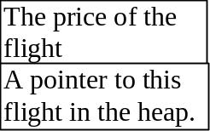

- Initialization of the array : O(n²)
Intialization of the heap O(n²)
Total O(n²).
- Finding price in the array remains O(1).
- Updating price in the array – have to update the price in the heap. O(log(n²)) = O (log n) – Why ?.
- Finding the cheapest line – the top of the heap, O(1).
- Deleting the line, again must be deleted from the heap, O(logn).

- Keep an additional heap for each line. Each such heap will store the price from a particular city to all other cities.
Each cell in the matrix will now contain: the price of the flight, a pointer to the global heap, a pointer to small heap:

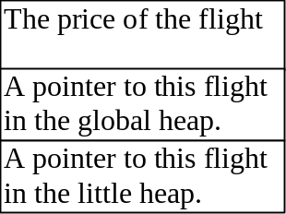

- Initialization of the array O(n²).
Initialization of the global heap O(n²).
Initialization of n small heaps (each of size n), O(n²).
Total O(n²).
- Finding the price in the array, O(1).
- Updating the price: updating in the array, and in two heaps O(logn).
- Finding the cheapest line – the top of the global heap, O(1).
- Finding the cheapest line from a particular city, the head of a smaller heap O(1).
- Deleting the line, delete in two heaps, O(logn).

The data structure in c. will look like: :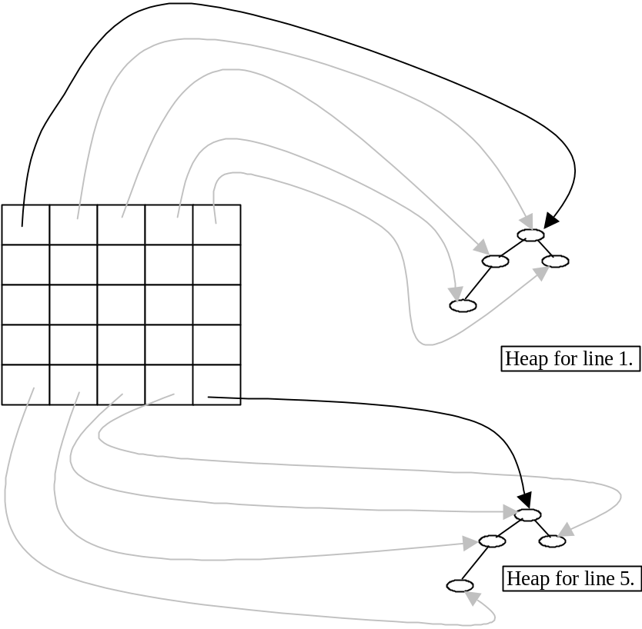

For example in row one, each cell is pointing to the global heap (doesn’t show in the picture), and to the heap of city 1. This heap contains the prices of all flights from city 1 to another city j.
Of course there is no flight from city one to itself, so the diagonal in the matrix keeps a pointer to the head of the heap.

(20 נק')
1
function a
default constructor of A class
end of function a
copy constructor of A class
destructor of A class
2
default constructor of A class
3
copy constructor of A class
4
operator = of class A
5
6
default constructor of A class
default constructor of A class
default constructor of B class
7
8
destructor of A class
destructor of A class
9
destructor of A class
destructor of A class
destructor of A class

( 30 נק' )
class Employee {

public:
Employee(const char* name, const char division);
virtual ~Employee();

const char* getName( ) const;
char getDivision ( ) const;

virtual void print() const = 0; // u can drop the =0 from here
virtual double wage() const = 0;

static unsigned getNumberOfEmployees();

protected:
char* name_;
char division_;

static unsigned employeesNum_;
};

class EmployeePerHour : public Employee {

public:
EmployeePerHour(const char* name, const char division, const double perHourWage);
virtual ~EmployeePerHour();

double wage() const;
void addWorkHours( int k);
void print( ) const {
Employee::print();
cout << "Wage per hour: " << perHourWage_ ;
}

static unsigned getNumberOfEmployeesPerHour();

protected:
double perHourWage_;
unsigned workHours_;

static unsigned employeesPerHourNum_;
};

class EmployeePerMonth : public Employee {

public:
EmployeePerMonth(const char* name, const char division, const long perMonthWage);
virtual ~EmployeePerMonth();

double wage() const;
void addJobPercentage( int k);
void print( ) const ;

static unsigned getNumberOfEmployeesPerMonth();

protected:
long perMonthWage_;
unsigned jobPercentage_;

static unsigned employeesPerMonthNum_;
};

class Manager : public EmployeePerMonth {

public:
Manager(const char* name, const char division, const long perMonthWage) :
EmployeePerMonth(name,division,perMonthWage) { managersNum_ ++ };

virtual ~Manager() {
managersNum_ --;
}

void print( ) const {
EmployeePerMonth::print();
cout << " Managing division " << division_;
}

static unsigned getNumberOfManagers() {
return managersNum_;
}

protected:
static unsigned managersNum_;
};

1.

#! /usr/bin/csh 0f

foreach dir ($argv[*] )
foreach file ($dir/* )
if (-f $file ) then
if ($file =~ *core* || $file =~ *a.out*) echo $file
else if (-d $file) then
$0 $file
endif
end
end

2.

a. echo $path[1]

b. set x = `date`; echo $x[1]

c. @ i = $j + $k

d. if ($a =~ *[cC]) echo match

e. set path = ($path /w/local/bin)

